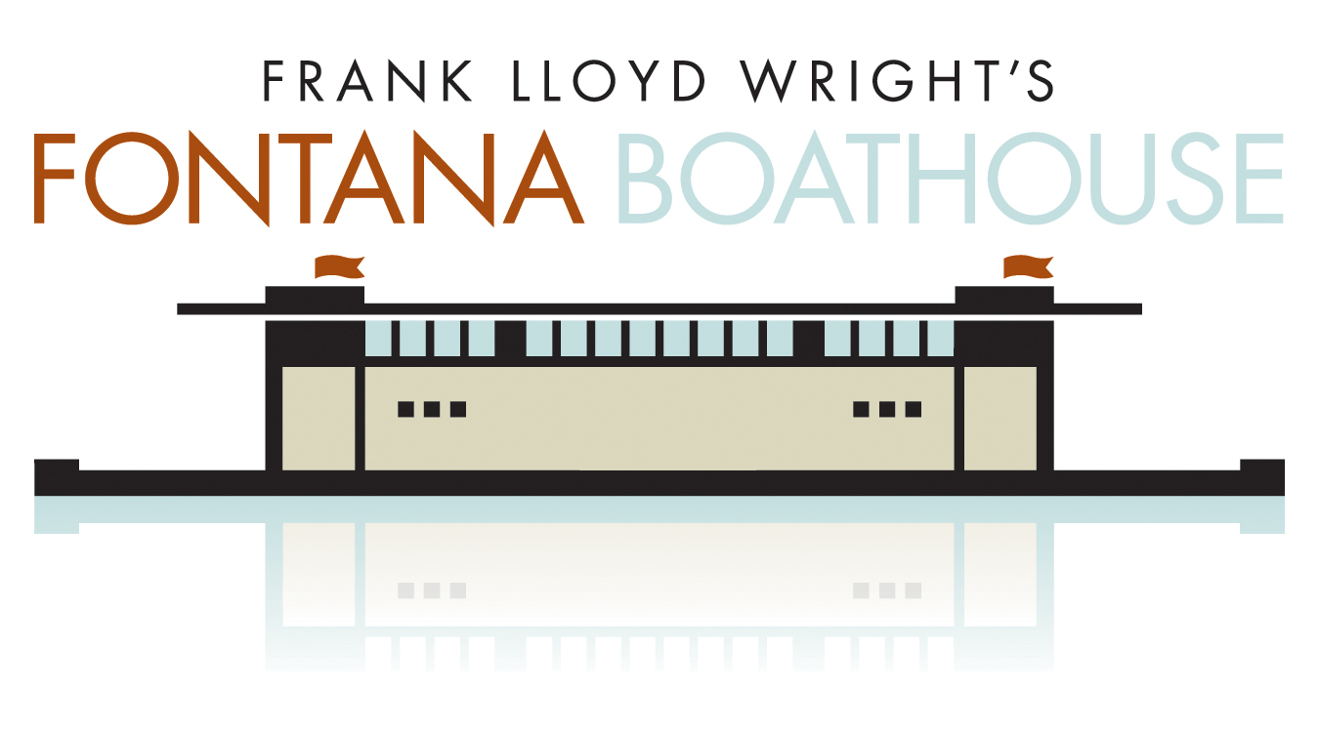

John Bennett Regatta
Sunday, May 4, 2008

The Officers and Board of Directors of the West Side Rowing Club would be pleased to have you attend the 2008 John Bennett Regatta.

The 2008 John Bennett Regatta will run North to South over 1,500 meters of the historic Black Rock Canal. Races will begin just to the south of Ferry Street Lift Bridge and finish at the West Side Rowing Club.

This year, we are excited to incorporate the new Frank Lloyd Wright designed boathouse into our regatta. Located just to the south of the existing West Side Rowing Club, this new addition to the West Side Rowing Complex will allow us to run a more efficient and safe regatta in fulfillment of Frank Lloyd Wright’s dream to build a functional boathouse. We hope that you can join us for the John Bennett Regatta with this fantastic addition to the West Side Rowing Club.

Regatta Rules:

Regatta Format:
- All events that require heats will be run as 1,500 meter time trials. Crews will begin rowing above the Ferry Street Lift Bridge and their time will begin when they cross the starting line.
- The top 4 crews from each heat will advance to the finals.
- All finals will be 4 boat races. The start of each final will be a floating start. All coxswains must listen and respond to the starting official to ensure a fair start. Failure to comply with the starting official will result in disqualification.

Course:
- The John Bennett Regatta is rowed over 1,500 meters of the Black Rock Canal. Crews will begin racing at the Ferry Street Lift Bridge and race south to the West Side Rowing Club.
- There will be a slight head current on the course, as crews will be racing from north to south along the Canal. Wind speed and direction will be determined on the day of the race.

Launch Site:
- All crews will launch from the docks located at the West Side Rowing Club. Crews will be called to the water no more than 45 minutes prior to the start of the event.
- All crews must launch with bows pointed towards the Canal.
- There will be a 60-second limit for all crews on the dock. The dock master will have the authority to impose penalties for excessive time on the dock.
- When you leave the dock for the heats, crews must stay to the east side (City side) of the Canal as they make their way to the start. Crews that interfere with racing boats on their way to the start will be assessed a penalty. No crew on their way to the start should proceed through the Ferry Street Lift Bridge until the Marshall on the water clears them to do so.
- When crews leave the dock for the finals, each crew must cross to the west side (river side) of the canal and make their way to the start. All crews must proceed to the start single file. Crews that interfere with racing boats on their way to the start will be assessed a penalty. No crew on their way to the start should proceed through the Ferry Street Lift Bridge until the Marshall on the water clears them to do so.

Starting Area:
- All crews must be in the marshalling area at least 10 minutes prior to the start of the event.
- Boats will be started in order of their bow numbers at approximately 15-second intervals for the heats.
- Boats arriving late to the start may lose their starting position or be excluded from the event at the discretion of the Starting Line Official.

Passing on the Race Course (Time Trial Heats only):
- A crew is deemed to be overtaking another crew when it has moved to within one length of open water of the crew ahead. On those portions of the course that are straight, a crew being overtaken shall move to the right and allow the overtaking crew to pass. – 2007 Rules of Rowing, Article VII.b
- Any violation of the passing rules will result in a 30 second penalty.

Buoys on the Race Course:
- A detailed course map will be available on race day.

Finish Area:
- All races will conclude in front of the West Side Rowing Club. There will be an official on land that will use an air horn to signal the finish of the race. The horn will sound once for each crew crossing the line.
- Once crews have crossed the finish line, they must keep rowing until they reach the red buoy beyond the Fontana Boathouse. Once crews have reached that point, they must turn to their port (towards the city) and begin rowing back towards the boathouse.
- All crews must stay between the wall and the red buoys when returning to the docks. Crews that enter the race course and interfere with racing boats will be given a 30-second penalty.

Return Dock:
- All crews will be returning to the Fontana Boathouse docks.
- There is a 60-second time limit on the dock.
- It is suggested that all coaches have the athletes shoes stored near the return dock and additional athletes to help clear the oars from the return dock area as crews come in.

Lightweights:
- Lightweight Men: Max of 155 lbs.
- Lightweight Women: Max of 135 lbs.
- Flyweight Men: Max of 145 lbs.
- Flyweight Women: Max of 125 lbs.
- The honor rule will be imposed for all lightweight events. No weigh-ins will take place at this regatta.

Definition of Categories:
- Freshman/Novice: Began Competitive rowing after August 1, 2007 or is in Grade 9 or lower.
- Junior: Any athlete in grade 11 or lower.
- Senior: Any athletes in grade 12 or lower.
- Lightweight / Flyweight: Any athlete that is at or below the specified weight for the event they are competing in.

Hot Seating:
- Hot seating boats or rowers requires a minimum of 45 minutes separation, but is always done so at your own risk. We will not wait for your crew!

Entry Information:
- All entries must be completed on Regatta Central (www.regattacentral.com).
- Mailed entries will be accepted if they arrive prior to the on-line due date.
- Payment can be made on Regatta Central or on the day of the event. If paying on the day of the event, please make checks payable to “West Side Rowing Club”.
- Entry Fee’s:
  - Eights: $65.00
  - Fours: $50.00

Day of Event Registration:
- Registration packets will be available in the upstairs Board-room of the West Side Rowing club on the day of the event.
- Each packet will contain bow numbers as well as back numbers and safety pins for each entry that requires a heat.
- Course maps and additional race information will also be included in the regatta packets.
- All entry fees must be paid in full before a program will receive their entry packet.

Event Parking:
- The main lot of the West Side Rowing Club will be reserved for trailer parking only.
- Please contact Matt Logue (mplogue@wsrc.org) if you will be bringing a trailer or traveling by bus to this event.
- There will be a shuttle bus transporting coaches and athletes from Front Park and LaSalle Park to Cotter’s Point beginning at 6AM and concluding after the last race.
- Additional parking information will be posted one week prior to the event.

Contingency Plan:
- All crews will be notified on May 2nd if the canal conditions require the race to be canceled.

Awards:
- Medals will be awarded to the first place crews of each event

Order of Events:
- Order of heats will be determined once all entries are submitted.
- The first heat will begin at 9am.
- The first Final will begin 20 minutes after the last heat ends.
- The event order for the finals will be:
  - #1 Boys Ltw. 4+
  - #2 Girls Senior 8+
  - #3 Boys Freshman/Novice 4+
  - #4 Girls Freshman/Novice 8+
  - #5 Boys Flyweight 4+
  - #6 Girls Junior 4+
  - #7 Boys Junior 8+
  - #9 Girls Senior 4+
  - #8 Girls Ltw. 8+
  - #10 Boys Senior 4+
  - #11 Girls Freshman/Novice 4+
  - #12 Boys Freshman/Novice 8+
  - #13 Girls Flyweight 4+
  - #14 Boys Ltw. 8+
  - #15 Girls Junior 8+
  - #16 Boys Junior 4+
  - #17 Girls Ltw. 4+
  - #18 Boys Senior 8+

