Traveling From the South:

Take I-95 North to Richmond, Virginia
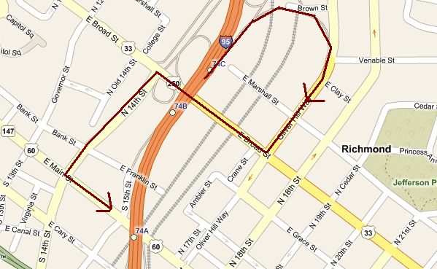

- As you approach Richmond, you will see the downtown area.

- After Exit 73, get in the right hand lane and you will be on the bridge crossing the James River.

- Take Exit 74C (Route 33; Route 250 Broad Street). Watch for merging traffic on your right while you are coming off the exit ramp and get in the right hand lane. You will see the Train Station/Clock Tower. Take the exit to “Broad Street East/Route 33”. (This is the curved area on the map.)

- Stay in the right hand lane (this is Oliver Hill Way) and at the first stoplight, take a right on tp Broad Street.

- Once you are on Broad Street, immediately get into the left hand lane. You will go under the train trestle.

- Take a left at the first stop light (14th Street) and stay in the left hand lane.

- Take a left at the second stop light (E. Main Street) and stay in the left hand lane. Stay on E. Main Street for 9/10th mile. (You will see the Libby Hill Monument straight ahead.)

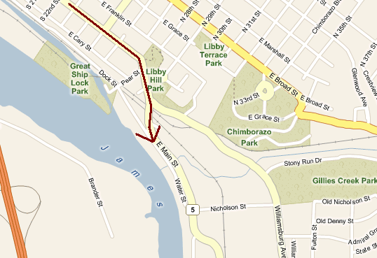

- The road will bend to the right to Route 5 and you will go under a train trestle.
- After you go under the train trestle, stay on Route 5 as it bears to the left as indicated on the following detail map.
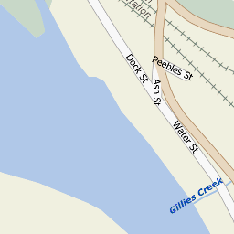
- Follow signs to Rocketts Landing.

- After the intersection of E. Main Street and Water Street, turn an immediate right on to the first driveway and you will be in the trailer parking area. Park perpendicular to the river.

- The Virginia Boat Club Downtown Boathouse is in the old Richmond Raft Company building at 4400 E. Main Street, just up river from the Rocketts Landing development area.

