ST. MARY’S PREP
LADDIE CUP
Rules & Regulations / Handbook

Changes | Page | Effective
Men’s Lightweights to be less than 150 lbs. | 4 | 2014
Minor grammatical updates | various | 2015
Updated points for 2x, 4x and 1x | 4 | 2016
Added clause for late to dock disqualification | 6 | 2017
Updated photos & sketches | 10 | 2018

TABLE OF CONTENTS

Introduction Page 3
Contacts Page 3
Regatta: Page 4
- General Information
- Weigh-Ins
- Regatta Rules
- Point Trophy
Directions / Parking Page 8
Course Map Page 10

Introduction
The St. Mary’s Prep Rowing Booster Club and Orchard Lake, St. Mary’s Preparatory welcomes you to the Laddie Cup held in the Village of Orchard Lake. We hope for clear skies and calm water on Orchard Lake. The event promises to be exciting for athletes and spectators. The Laddie Cup Regatta Committee will award a Men’s and Women’s point trophy, individual race medals, and an overall point trophy.
This package contains information you may find useful. Our Regatta Committee has made every effort to make the day enjoyable for your team and fans. Should you have any recommendations; we welcome them. We will have directions for parking, areas marked for boat trailers, lay-down yard, and your hospitality tents. Should you need assistance; please do not hesitate to contact one of the Regatta Committee Chairs; see Regatta Central.
We ask that you do not bring pets to this regatta, and St. Mary’s Preparatory is a SMOKE FREE campus.
Good luck to you and your team.

Contacts
Please refer to Regatta Central, Laddie Cup for all contact information.

General Information & Definitions
COACHES AND COXSWAIN MEETING: St. Mary’s Preparatory corner house per schedule.
COMPETITOR AGE: Rowers in this event must not have reached their 19th birthday.
GENDER: Only males may row in Men’s events. Only females may row in Women’s event.
COXSWAINS: Coxswains may be of either gender, and of any skill or age classification (not withstanding the age maximum). There is no weight minimum for coxswains.
EVENT LIMIT: None
SCHOLASTIC: Entries must be comprised of students in grades 9 through 12 and row representing that school or club during the spring season (March-June) unless a waiver is granted.
NOVICE: A novice rower began rowing after the Midwest Scholastic Championships of the prior year.
FRESHMAN: An athlete currently enrolled in grade 9.
JUNIOR: An athlete currently enrolled in grades 9, 10, or 11.
VARSITY: Open event for athletes complying with gender, age, and scholastic requirements.
LIGHTWEIGHT: A lightweight crew is one that complies with the requirements below.
Men: The lightweight crew shall have no rower who weighs more than 150 lbs.
Women: The lightweight crew shall have no rower who weighs more than 130 lbs.
REGATTA RACE POINTS:
 | 1st Place | 2nd place | 3rd Place
8+ | 30 | 25 | 20
4+ | 20 | 15 | 10
4x | 20 | 15 | 10
2- | 10 | 8 | 6
2x | 10 | 8 | 6
1x | 5 | 3 | 1
A team may earn points once per race, with the 2nd boat blocking. Ex. If a team wins 1st and 2nd place; points will be awarded for 1st place only. No team will win the 2nd place points.
Weigh-in will be by challenge only.
This is not the Midwest Regatta and we hope to have a day of enjoyment for all. There will not be a weigh-in, and all Head Coaches are responsible for their athletes complying with the weight limit.
Challenges must be within 30 minutes of race conclusion by notifying a race official. Should a challenge be made, both boats (boat posting the challenge and challenged boat) may be subject to the weigh-in rule at the Race Marshall’s discretion. The Marshall’s decision is final. Should a weigh in be required. The following apply:
- Crewmembers must weigh in wearing their crew uniform, identical in color and style to others on the crew.
- Members of each crew must weigh in together and be accompanied by their coach or a club official.
- Crewmembers are to step on the scales in the order in which they row in the boat, bow to stern.
- Coxswains do not need to weigh-in.
- Clerk of the scales will communicate only with the coach or club official.
- Coxswains: Coxswains may cox in any boat, regardless of gender, novice, or varsity status. There is no weight minimum for coxswains.
Any rower exceeding the weight limit will result in the disqualification of the boat when weigh-in is post-race.
At the coach’s discretion, rowers may pre-weigh. Upon meeting the weight limit, the rower will receive a wristband and their name recorded by the race officials. Please contact a race official prior to start of the regatta if you wish to pre-weigh.

Regatta Rules
- Quick Release: Check your equipment for race readiness, including the proper tying of heels (3 inches). Releases may be checked at the dock as the boats approach the launch area.
- Weighing Boats: Boats will not be weighed.
- Bow Balls: Bow balls must be secured to shells before launch. Shells without bow balls will not be allowed to race.
- Bibs: Bibs will be provided at the launch area if used. Bibs must be returned.
- Bow Numbers: Bow numbers will be supplied at the launch area and must be returned to the dock master on return to the beach following a race.
- Lane Numbers: Lanes at the regatta site may not be numbered. Rowers shall enter lanes as directed by the Regatta Marshall.
- Boat Storage: Boats are to be stored in marked areas only. Please provide your own boat stands and secure all boats not in use. Trailers shall be parked in the designated area. All equipment must be removed from the regatta site by sunset Saturday evening.
- Starting Platforms: The event may be open water or platform. Event configuration will be announced at the coxswain meeting.
- Late to Start/Launch: All crews must be on time to the start area. Crews late to the starting line or marshalling area may be disqualified. The dock will close 5 minutes after the 3rd and last call. Regatta officials &/or Dock Master, upon his discretion, may disqualify late boats to the dock.
- Protests: Any crew wishing to protest shall raise their hands after completing their race. Only on water protests will be acknowledged. Do not leave the Finishing Area (do not pass the 1st dock) until your protest is filled. Protests will be adjudicated by the regatta Marshall.
- Weigh-in: Lightweight category weigh-in will be by challenge only. Each oarsman will be given two opportunities for weight check.
  - Upon successful weigh-in pre-race, the athlete is given a wristband.
  - If weigh-in by challenge, see earlier rules.

- Disputes: This regatta is for the enjoyment of the athletes and spectators. As such, these rules may be modified by the unanimous concurrence of each team’s head coach.
Point Trophy
The Laddie Cup will award individual medals to 1st place, 2nd place and 3rd place finishes. The Men’s and Women’s Regatta Trophy is awarded to the team with the most points. A school may receive points once per race with blocking in effect. However, the 2nd boat will receive medals. The winners will receive a trophy and their school name scribed on the perpetual trophy.
Beginning in 2014, the Laddie Cup will award an overall point trophy based upon performance of both the men’s and women’s crew. Blocking rules will be in effect.
Please see General Information & Definitions for clarification.
Jack “Laddie” LeBlanc
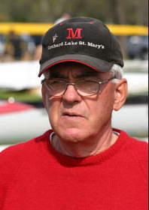
Head Coach: 1979-1996
Coach: 1976-1996

St. Mary’s Preparatory rowing began in 1976 when Judson Ross and Jack “Laddie” LeBlanc hauled there equipment to Orchard Lake and offered to coach a prep program for St. Mary’s. For the next three years, Judson coached the crews with Jack. But with Judson’s failing health, he turned to Jack with a silver-tongued plea to take over the program and passed across his earthly finish line to his Lord a few years later. In 1979, Laddie became St. Mary’s Preparatory 2nd Crew Head Coach. Under Jack’s guidance, he developed hundreds of memories for hundreds of OLSM crewmen across the gunwales. He certainly added his best to the legacy he was entrusted with by Judson.
Under Jack’s guidance, St. Mary’s Prep Crew achieved success in the State of Michigan, at the Midwest Regatta, Stotesbury Cup Regatta, the Canadian Schoolboy Championships, and US National Championships. Jack retired as Head Coach in 1996. Jack LeBlanc passed in 2014.
Direction – Regatta
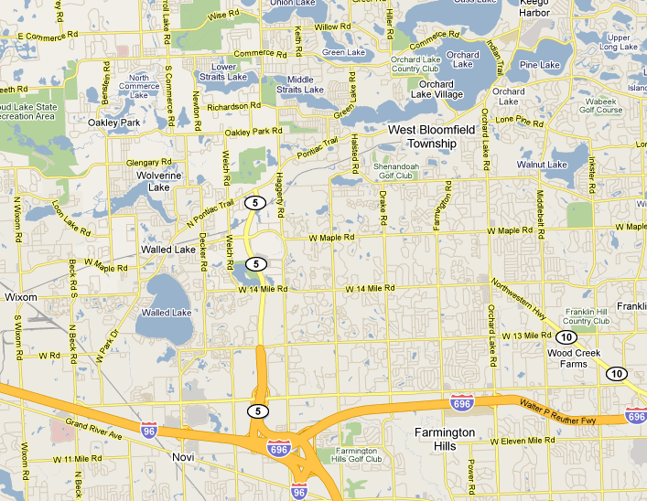
Traveling from the West: Drive East on I-96 to Novi and the I-275/I-696 interchange. From here, you have two ways to reach Orchard Lake, St. Mary’s Preparatory:
- Continue on I-696 to Orchard Lake Rd and head North on Orchard Lake Rd.
- Take M-5 North to Pontiac Trail Rd. Head North on Pontiac Trail Rd to Orchard Lake.
Traveling from the South: Drive North on I-275 to the I-275/I-696/I-96 interchange. From here, you have two ways to reach Orchard Lake, St. Mary’s Preparatory:
- Take I-696 East to Orchard Lake Rd and head North on Orchard Lake Rd.
- Take M-5 North to Pontiac Trail Rd. Head North on Pontiac Trail Rd to Orchard Lake.
Parking
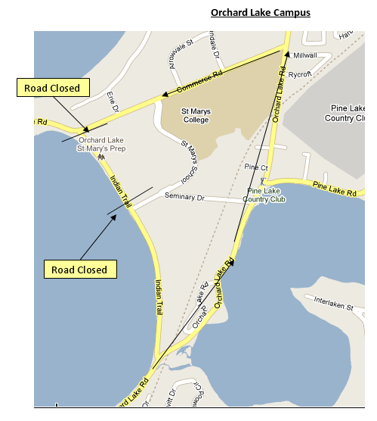  Parking  Parking | Public Parking: Indian Trail will be closed between Pontiac Trail and Commerce Rd from 7:00 am until 3:00 pm. You are recommended to proceed north on Orchard Lake Rd. to Commerce Rd. and proceed to parking. Follow the parking signs
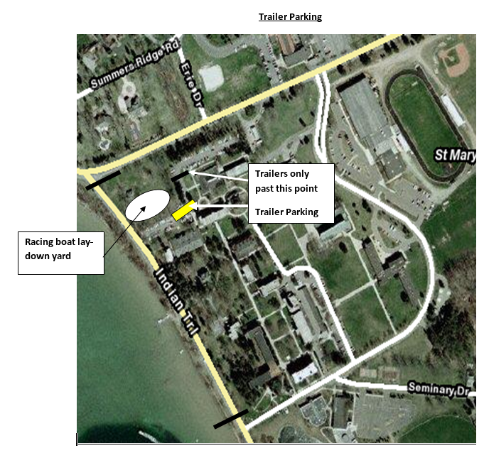  1-Way Boat Trailer Traffic | Boat Trailers: The designated area for boat trailers is near the lay-down yard. Turning into the parking lot can be tricky. Drivers should approach the parking from westbound Commerce Road into the parking area.

.REGATTA COURSE – ORCHARD LAKE
We will race on Orchard Lake with boat launch from the dock and boat retrieval at the lakeshore. This is an open water start. Course alterations will be at the discretion of the Water Official and announced at the Coxswain Meeting. This is a 1,500 meter event.

