

EMERGENCY ACTION PLAN
Updated September 26th, 2019

In Case of Emergency Call 911

Royal Canadian Henley Rowing Course
Henley Island Drive
St. Catharines, ON

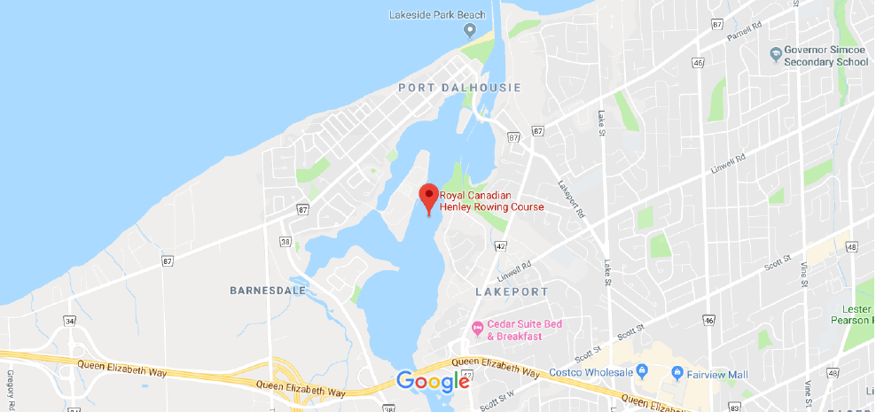

From Main Street, turn onto Henley Island Drive (across from Saint Ann Catholic Elementary School). After crossing the bridge, turn left to the main parking lot. Follow the large MEDICAL signs to park directly behind the medical building.

Lay Out of Location

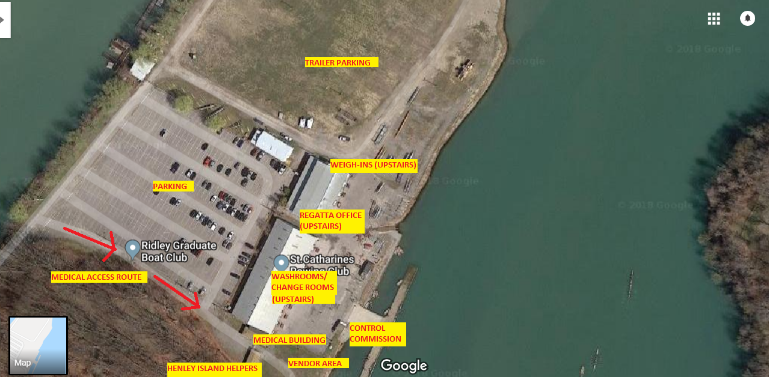

Emergency Procedures indicate that EMS should be contacted if any of the following situations occur:
- Victim is not breathing or was not breathing
- Victim is bleeding profusely
- Victim lost consciousness for any period of time
- Injuries occur to back, neck or head
- There is a major trauma to a limb
- Victim suffers cold water emergency
- Serious assault with or without a weapon
- Fire
- Any other situation at the discretion of the Charge Person on site at that time

ROLES IN AN EMERGENCY

Charge Person
- Lead Coach, staff or senior volunteer on site with First Aid training –
JEANNE PAWLUK (289-407-8777)
- Monitors possible danger to themselves and others
- Responsible for first aid – including decision to contact EMS and victim care
- Direct others to complete assigned tasks (see below)
- Needs to know location of Emergency Information for all participants and be able to access
- Ensure Incident report is completed and appropriate follow up is completed including alerting Andrea Miller (andrea@rowontario.ca 905-518-0301)

Call Person
- As directed by charge person call EMS
- Have knowledge of situation to be able to communicate details to EMS
- Have knowledge of site to communicate directions to 911 Operator

Other Roles to be Assigned
- Greet EMS at site entrance
- Runners to get First Aid Kit, AED, ice, blankets etc.
- Ensure everyone else gets off the water immediately and stays off the water
- Controls the crowd

OUA Championships – Weather Action Plan

  - Weather Action Plan for OUA Championships regatta held at the Royal Canadian Henley Rowing Course, St. Catharines ON
This weather plan provides an outline of the steps to be taken in the event that weather conditions become a safety concern.

The Chief Umpire or Regatta Chair will monitor weather forecast through web sites (radar, local weather stations and local weather forecasts), as well as by phone with One on One Environment Canada Weather.

Call the Storm line toll free at 1-800-463-9463

1.0.1 The Chief Umpire or Regatta Chair will consult some of the following Websites as required:

a) Environment Canada Marine Forecast - Western Lake Ontario: https://weather.gc.ca/marine/forecast_e.html?mapID=11&siteID=08207
b) Wind finder (St. Catharines/Lakeshore): https://www.windfinder.com/forecast/st_catherines_lakeshore
c) Sail flow (St. Catharines / Port Weller): https://www.sailflow.com/map#43.204,-79.252,12,1,!828,2
d) The Weather Network (hourly forecast, and radar forecast): https://www.theweathernetwork.com/ca/hourly-weather-forecast/ontario/st-catharines
e) Accuweather: https://www.accuweather.com/en/ca/st-catharines/l2m/hourly-weather-forecast/49567

1.1 Initiating the weather Action Plan procedures:
The Chief Umpire and Regatta Manager meet to review the weather status – before the regatta, during the regatta, as required, when notified conditions are changing for the worse. The Weather Action Plan is set into action when:
    - The Chief Umpire and/or Regatta Manager determine that action is required to ensure safety.
The required actions may include the following:
- Holding additional boats from launch and finishing the races on course, or:
- Immediately calling all crews off the water, or:
- Continuing to monitor weather and review additional data.

    - If action is required the following are the responsibilities of the Regatta Chair, Regatta Manager and Chief Umpire.
- Chief Umpire informs the jury (control commission, start line, race umpires, and finish) of the action plan and instructs the Regatta Control Commission to monitor and account for all boats on the water by club or crew. The Chief Umpire will also communicate the action plan to the Safety Boat director for safety boats on the water.
- The Regatta Chair informs the Organizing Committee and the Committee Directors of the action plan. The Regatta Manager ensures that a public announcement is made regarding the action plan.
- The Regatta Manager informs the Ontario University Athletics Association and all participating member institutions.

1.2 Procedure for Evacuation from Water:

1.2.1 Control Commission:
The Control Commission will account for all crews on and off the water. The Control Commission will monitor and record all crew names and follow up with crew coaches to ensure all crews are off the water.

1.2.2 At The Starting Line:
a) The Starter at the start will notify/announce to all persons in the starting area that they are to return to the launching area. Umpire and/or safety launches in the area will assist in evacuating umpires and volunteers from the start platforms.
b) The Starter will observe all crews at the start including warm-up area to ensure they have been informed of the plan and start heading back to the launching area (unless there are crews sheltering there, in which case the Starter will stay with the crews). The safety boat at the start will follow the last crew back to the launching area.

1.2.3 Race Umpire and Safety Boats:
Safety boats will follow crews back to the launching area and will follow the last crew back to the launching area to be the last off the water. If required, crews can also dock at the grandstands and take shelter under the grandstands.

1.2.4 At the Finish Line:
Chief Finish Judge will monitor all crews at the finish and communicate to Control Commission to ensure all crews are accounted for. If required, crews can also dock at the grandstands and take shelter under the grandstands.

1.2.5 At the Launch Docks Or Area:
Dock Marshals will ensure crews quickly exit launch area. During course closure, the Dock Marshal will allow boats to dock from either direction ensuring that docking shells do not crossover docking patterns.

1.2.6 Coordination of All Umpires:
Chief Umpire, Regatta Manager and Chief of the Control Commission will confirm everybody (crews, race umpire boats, safety boats, start personnel and others) are safely off the water.

1.3 Following Evacuation from Water:
The Regatta Manager and Chief Umpire, as well as one representative from each participating institution, will meet to review and discuss options. A decision will be announced as soon as possible regarding any delays.

1.4 Delay Contingency Plan:
The Local Organizing Committee can reschedule races earlier or later in the day for safety reasons in the event of bad weather. Any changes in the schedule will be announced by the Control Commission. (This will also include shortening the length of races). It is the responsibility of the crew and club coaches to monitor and stay current with the schedule.

Any changes required by a weather delay will supersede the published related requirements of the RCA Rules of Racing. During the condensed schedule, the Race Umpire has the discretion to determine whether a crew is maintaining a competitive position in the race. If the Race Umpire determines this is not the case, the Race Umpire can make the call to exclude that crew from the race and direct them to remove themselves from the course. No allowance will be made for athlete conflicts due to reducing time between races and substitutions will not be allowed.

1.5 Schedule Change Options Due to Weather Delay:
The following represent options possible for the OUA Championships regatta. This is not an exhaustive list; it is ultimately the Chief Umpire and Regatta Manager’s decision to determine the best option, in consultation with one representative from each participating institution:
- Delay races until as late as possible that all races can still be completed before sunset. Racing will not take place after sunset.
- Condense the Varsity Heat and Development races, then race Varsity finals on Friday (thus condensing the two days of racing into one day). The time between the Varsity finals cannot be reduced; Varsity finals must race at 15-minute intervals. In extreme situations, the Development races may need to be canceled to allow all varsity racing to be completed on Friday.
- Postpone racing, with Saturday afternoon and Sunday as potential alternative racing days.
- If Varsity heats have already been completed, and it is determined that it is not possible to continue racing, final results and placing may be determined based on finish time in the heats.

The Regatta Manager and Chief Umpire, in consultation with one representative from each participating institution, will decide on the requirements of the schedule change. The Regatta Chair will communicate with the Regatta Committee, committee Directors and ensure announcements are made and communicated to all areas of the regatta (Control, public, Start and Finish). A coaches’ meeting will be held to communicate any schedule change. Changes will also be publicly shared on RegattaCentral and social media.

