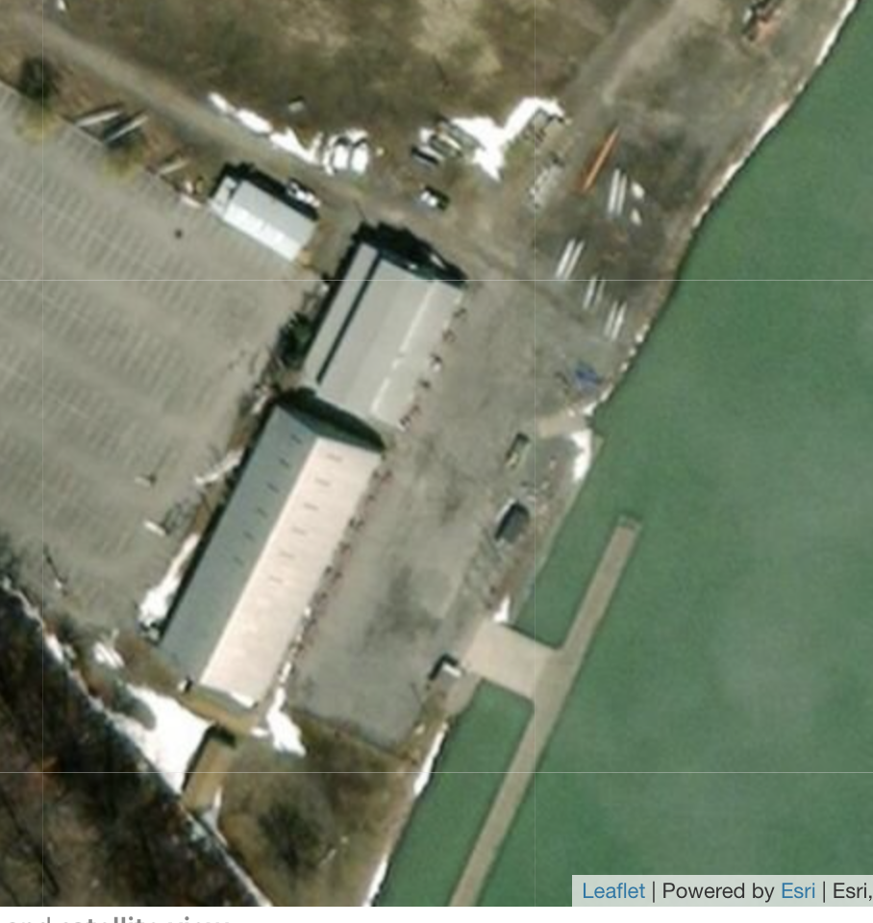

CAR & BUS

PARKING

TRAILER AND BOAT COMPOUND

ONLY

Regatta Office

WASHROOOMS

SHOWERS

HIH FOOD

CONCESSION

MEDICAL

CLERK OF COURSE

IN DOCK



OUT DOCK

Neil Campbell Centre

Athlete ergs and rest area

Weigh-in Room

Quiet Study after weigh-ins