US Rowing 2016 Southwest Masters
Regional Championships
Lakeside Park – Lake Merritt
568 Bellevue Avenue, Oakland, California
Sunday, July 24, 2016

Welcome to Lake Merritt, Oakland, California, for the 2016 Southwest Regional Masters Regatta on July 24, 2016. Lake Merritt Rowing Club (LMRC) is excited to announce it will host this regatta on Lake Merritt in Oakland.

Information and Important Links

US Rowing Event Announcement:
http://www.usrowing.org/events_new/details/2016/07/24/default-calendar/2016-usrowing-southwest-masters-regional-championships
US Rowing Registration and Event Information:
https://www.regattacentral.com/regatta/index.jsp?job_id=4588&org_id=3870
Lake Merritt Rowing Club is hosting this event (Venue, Parking, FAQ):
http://lakemerrittrowingclub.org/events/sw-masters-regional/
Volunteers needed for the planning, preparation and throughout the Regatta!
http://www.signupgenius.com/go/10c0444adaa2fa75-july

Onsite Registration Note: All competitors must come to the Registration Desk, present picture IDs, and receive their credential for the regatta before competing. The registration desk will be open:
Saturday 7/23 - 12:00PM to 7:00PM
Sunday 7/24 - 6:00 AM to the end of racing
All competitors must be a full "championship" member of USRowing, and have signed the USRowing waiver. Both membership and waiver can be completed on the USRowing website.

Coxswain Meeting 6:30 AM on Sunday at the launching area courtyard, next to the registration desk. A REPRESENTATIVE FROM EACH TEAM MUST ATTEND this meeting and convey any needed info to the team's crews and scullers. IN ADDITION, Race and Safety Information needed by competitors at this regatta will be available in video format at https://youtu.be/SbVGG8J9WLo Coaches and all competitors directing a shell during racing or practice are RESPONSIBLE TO KNOW ALL SAFETY INFO contained in the video, and it is strongly recommended that all competitors watch the video, which will also be available for viewing at the regatta.
About the Regatta…

Join LMRC for a day of fun on the lake!

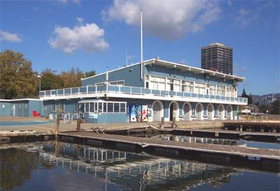
What: Lake Merritt Rowing Club (LMRC) is excited to announce it will again host, after a three year gap, the U.S. Rowing 2016 Southwest Masters Regional Championships on Lake Merritt in Oakland. We expect clubs from all over the West Coast. In the past clubs from the East Coast, Mid West and South and even Canada have competed. Races will be on probably five-minute centers in Lake Merritt’s seven-lane course. The event is a regional competition with top finishers qualifying for the National Masters Championship in Massachusetts in August of this year.

Driving Directions - Click here for a map of our location: http://goo.gl/maps/YjHj
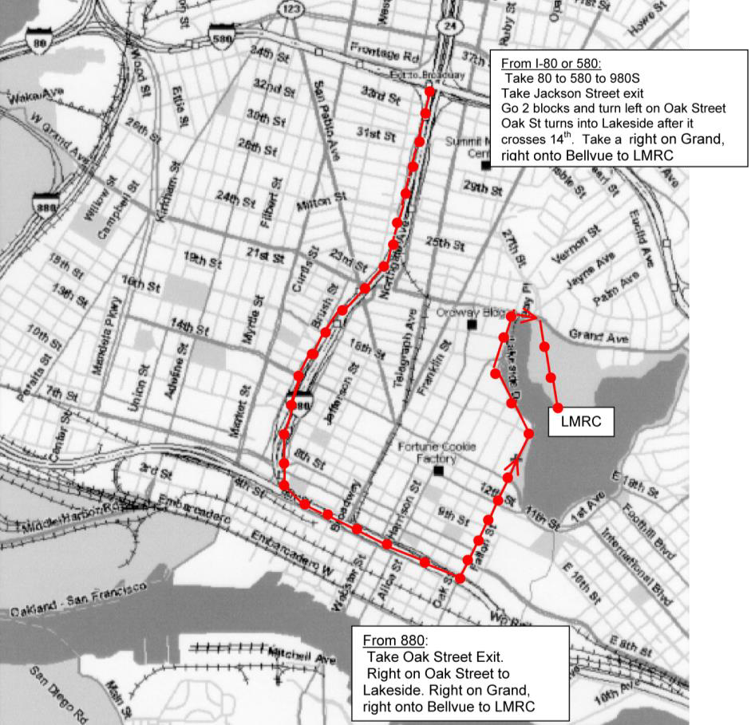
From the South Bay: Take 880 North; take Oak Street exit; right onto Oak; go past the Lake Chalet; continue approximately 1/3 mile, following the lake on your right; turn right at the end of the “finger” on Grand Avenue. Continue a couple blocks and take a soft right after the light at the park entrance, onto Bellevue Avenue (one‐way). Pay $5 entrance fee to the City attendant at the kiosk. Continue along Bellevue Avenue to the light blue building on your right – the City Sailboat House.

From the North Bay: Take 580 East past downtown Oakland to the Harrison Street exit; turn right onto Harrison at the bottom of the off‐ramp; continue approximately 1/2 mile; then turn left onto Grand (the lake is now in view); continue a couple blocks and take a soft right after the light at the park entrance, onto Bellevue Avenue (one‐way). Pay $5 entrance fee to the city attendant at the kiosk. Continue along Bellevue Avenue to the light blue building on your right—the City Sailboat House.

The following area map shows routes 80 from San Francisco, Routes 880/580 from the south, and routes 580 and 24 from the north. Use “568 Bellevue Avenue, Oakland, CA” for the address in your GPS device.

https://www.google.com/maps/place/568+Bellevue+Ave,+Oakland,+CA+94610/@37.8040608,-122.26529,12z/data=!4m5!3m4!1s0x808f87490776a577:0xe2397387f13c9e36!8m2!3d37.8051459!4d-122.2573936?hl=en

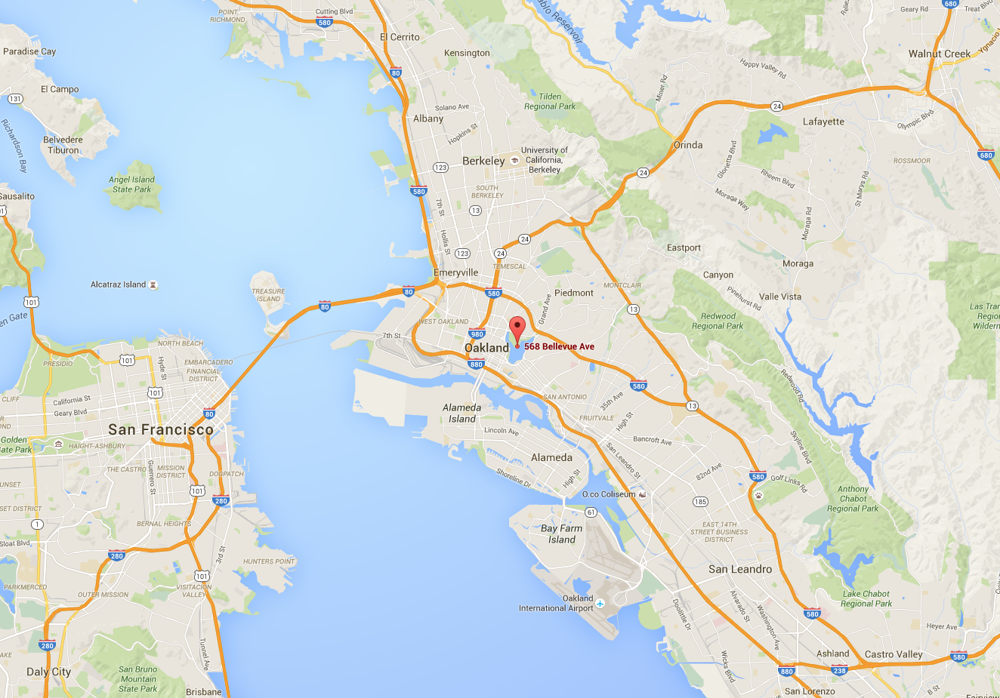

Event Overview
The Lake Merritt Sailboat house within Lakeside Park on Bellevue Avenue is the central location for all Regatta activities:

Rowers/Coxswains –
- Regatta Registration, Weigh-ins
- Launching and Landing Docks
Safety
- Boat Tie-in Check
- First Aid
- Heat Relief
Spectators/General
- Vendors (Coffee/Food/T-Shirts), Bathrooms
- Lookout Points
Volunteers –
- Volunteer tent

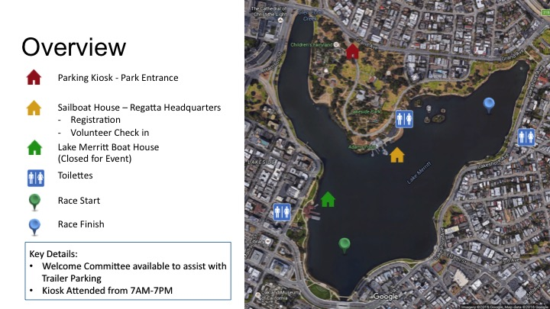

Parking (Cars and Trailers)
Parking is available inside Lakeside Park on Bellevue Avenue. The cost on weekends is $5 for all day parking. The parking operating hours are from 7:30am until dusk. The Bellevue Ave. and Pathway Improvement project will be in construction from April 26, 2016 through September 2016. During portions of the construction there will be limited parking and pedestrian access along Bellevue Avenue, though all facilities will remain open and accessible.

You should be able to re‐enter. If you are car‐topping, explain to the attendant that you are dropping off your boat and may need to swing around and re‐enter to park. The city should waive any additional fee. There is parking along the road after you enter the park (Bellevue Avenue). Carpooling is encouraged. Metered parking is available along the roads surrounding the park but the time available won’t last for the whole day.

Car-Topping
If you are car‐topping, please unload your boats in the drop‐off zone and then re-park your vehicle. The drop‐off zone will be marked in chalk and is the area just past the Sailboat House parking lot entrance driveway.
There is no permanent parking in the drop-off zone AT ANY TIME!

Please note: When you arrive with your trailer, you will be greeted by a volunteer who will ask you to complete a form providing us with your vehicle/driver contact information (primary and backup) for your safety. If we do not receive this, you may be subject to tow.

Trailer Parking

Trailer parking has been reserved along Bellevue Avenue in close proximity to the Sailboat House in designated/posted areas. Plan to arrive early for the best spots! There will be two security staff present beginning at 5:00 p.m. on Saturday, July 23rd until 5:00 a.m. on Sunday, July 24th; however, note that they are canvassing a large area, and we cannot be liable for theft or vandalism. Please don’t leave valuables in trailers/cars. The parking lot next to the Sailboat House will be reserved for staff and volunteers, but boats may be unloaded onto racks and slings along the grassy area next to the road, as directed by Parking Control. Thank you in advance for following volunteer staff instructions!

There are low-hanging branches as you drive along Bellevue Avenue, stay clear!

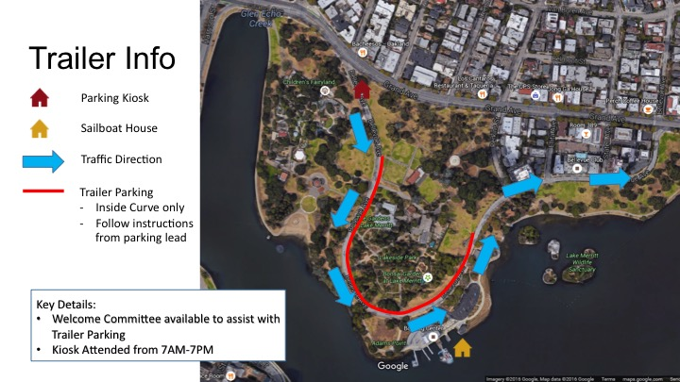

Where to Sling Your Boats
You may place your boats in slings in the grassy areas along Bellevue Avenue. Please follow the instructions of the staff and volunteers. You will not be allowed to sling your boats or set up a day camp location in the planter area between the parking lot and Bellevue. This is a change from last year. Please be courteous when finding a space for your boat(s). Also make an effort to provide room to your neighbors. We are all in this together.
Do not obstruct other crews.

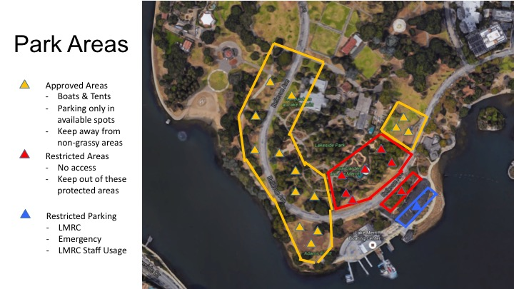

There are several changes at the venue since the last time Lake Merritt Rowing Club hosted this event in 2013. The Sailboat House and environs have been renovated. Trailers will park along the left side of Bellevue Avenue, but clubs have to set up their day camp locations on the lawn area on both sides of Bellevue. No day camp locations will be allowed in the planter strip between the parking lot of the Sailboat House and Bellevue Avenue. There is absolutely no overnight camping. In addition to the coaches, coxswains’, and scullers’ meeting this year, we have posted a safety and informational video on our website (linked above). All attendees will be required to watch the video prior their race. You may view the video online or you may watch it in the weigh-in area. A representative must still attend the pre-race meeting.

Regatta Operations and Key Points of Interest

The following map shows the key points of interest at the Lake Merritt Sailboat house:

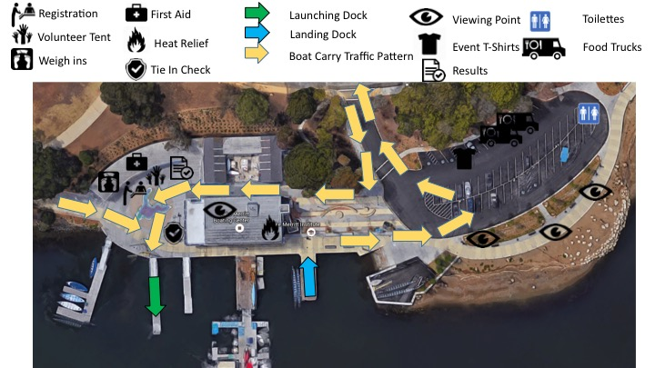

Please note the Registration, Volunteer, Tee-shirt sales, Food Trucks, Bathrooms, First Aid and Heat Relief locations.

Launching and Return Docks

The launching docks are at the far side of the venue near Registration. Boats heading for the launch dock may walk boats through the alley between the Sailboat House and the fenced pen or down the concrete path on the west side of the Sailboat House. Please cooperate with staff and volunteer so as to eliminate “traffic jam.” Equipment will be checked (see Venue Map on next page). All boats (sweep and sculls) should approach the launching dock bow first.
The return/take-out docks are east of the Sailboat House and require a step up from the landing/take-out dock. It is recommended that all sweep boats return bow first. Sculls can approach bow or stern first, whichever is more comfortable. Boats coming off the Lake will turn right into the parking lot, make a U-turn and then head up the driveway toward Bellevue Avenue.

Suggested Boat Handling Directions
Everyone: Have your other team members/coaches meet you at the take-out dock to collect your oars and give you your shoes–to keep the traffic moving.
Sweep Boats at take-out dock: Once the crew has the boat out of the water and to shoulders, angle the bow toward the main dock. The coxswain should then support the bow and have the bow 4 rowers, using the stairs as possible, move to the upper/main dock a pair at a time while lowering the boat to waist. The coxswain should then move to the stern, staying on the main dock and assist at the stern while the stern 4 move to the upper/main dock a pair at a time while going to waist. Once on the main dock, take the boat back up to shoulders and proceed to the washing area, then back to your slings.

Scullers at take-out dock: Use the sets of steps which will allow you to easily step up with your single or double. For quads, you may use the steps or ask the dock master for assistance, following the boat handling described above, as needed.

Boat Traffic Patterns/Course Map
Please review the Venue and Course maps carefully and note the boat traffic flow on land and on the water. All races start at “The Dam” near the Lake Chalet and finish at “The Embarcadero.” The lake can get shallow, so please stay away from the outer edges of the lake.

For your safety and that of all others, all shells must follow the traffic pattern.

Launching: Allow at least 30 minutes before your race to warm up. Dock space is limited; launch as quickly as possible. Bring oars to the dock before you launch. Tie in on the water.
Warm-up: Keep the buoys on your port side in the finger.
Pre-race area: Wait for your race in the area before the dock. When called to the start, you may row onto the course into your lane. BACK into your stake boat; you must be locked on two minutes prior to your race’s start time. Alignment will be done silently, by radio. To hold your point, scull the bow into position. DO NOT take full strokes, which will pull you out of the stake person’s grasp.

All crew must be accomplished in staging quickly onto a start platform.

Finish Area: Run-out room is limited, especially in lanes 6 and 7. Please clear the finish area quickly; a race may follow yours in only a few minutes!
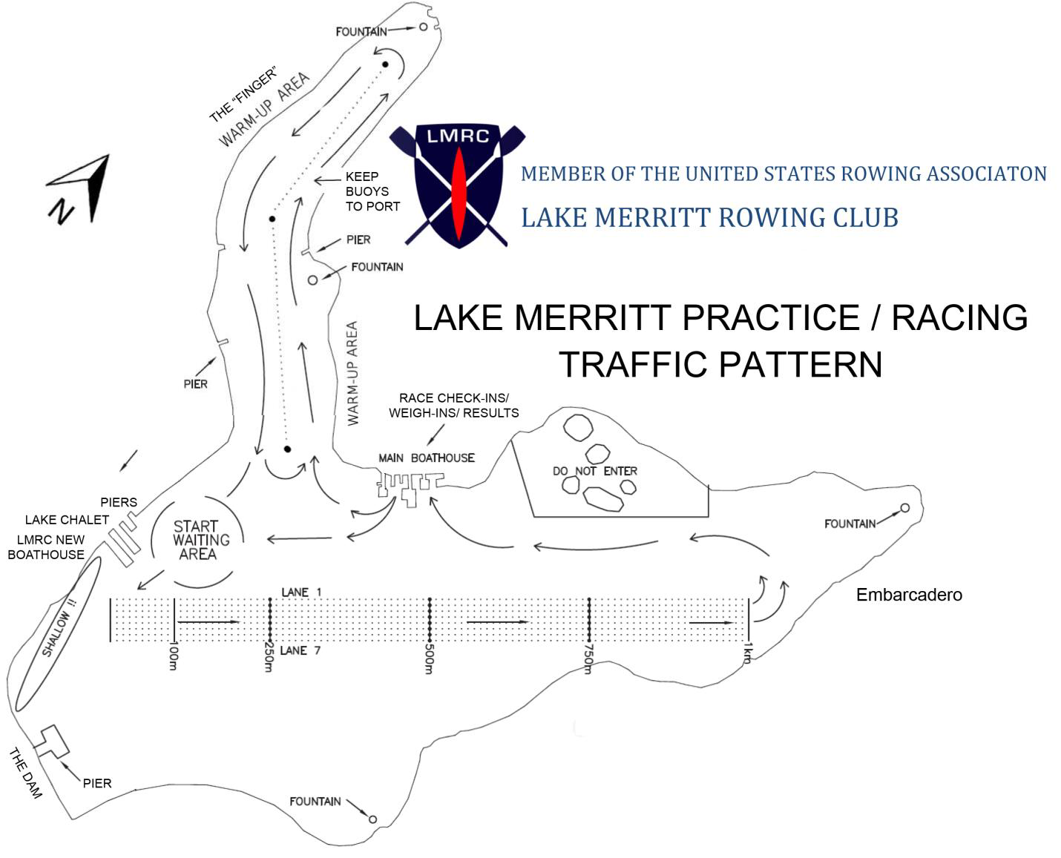
FAQ (Frequently Asked Questions)

Southwest Regionals FAQ

Q: When and Where is the Coaches and Coxswains meeting?
A: Yes, there is a brief meeting at 6:30 AM on Sunday at the launching area courtyard, next to the registration desk. HOWEVER, Information needed by competitors at this regatta is now available in video format at () Coaches and all competitors directing a shell during racing or practice are RESPONSIBLE TO KNOW ALL SAFETY INFO contained in the video, and it is strongly recommended that all competitors watch the video, which will also be available for viewing at the regatta. A brief meeting will be held at 6:30 AM on Sunday in the launching area courtyard, next to the registration desk to answer any questions and provide last minute information such as scratches and schedule changes. A REPRESENTATIVE FROM EACH TEAM MUST ATTEND this meeting and convey any needed info to the team's crews and scullers.
Q. Do I need to register?
A: Yes, all competitors must come to the Registration Desk, present picture IDs, and receive their credential for the regatta before competing. The registration desk will be open from Noon to 7:00PM on Saturday, July 23rd and from 6:00AM to end of racing on Sunday July 24th. All competitors must be a full "championship" member of USRowing, and have signed the USRowing waiver. Both membership and waiver can be completed on the USRowing website.

Q: Do coxswains need to weigh in?
A: Yes. Weigh-ins will begin at 6AM on Sunday morning.
Info on Weigh-ins: All rowers in races with lightweight classifications and all coxswains are required to weigh in on race day in accordance with USRowing rules. All athletes shall weigh-in in racing attire. Team boats must weigh-in together, although there will be no averaging of the crews. Coxswains who are required to carry weight must provide their own additional weight and have it verified by the weigh-in officials. The weigh-in schedule will follow USRowing rules of racing. Crews and coxswains must weigh in at least one hour, but not more than two hours before their first scheduled lightweight event. Crews and coxswains only need to weigh in once. Minimum Weights: Coxswains for Men's events 120 lbs. min, Ltwt. Men 160 lbs. max, Coxswains for Women's events 110 lbs. min, Ltwt. Women 130 lbs. max, Coxswains for Mixed events 120 lbs. min

Q: Is there a scale to test my weight before I weigh in? Can I test myself on the scale on Saturday to see if I am going to make weight on Sunday?
A: Yes. The scale will be set up at registration starting at 6AM on Sunday. If you would like to test your weight on Saturday, check with the information table or find a red-shirted event staff member and see if he/she will plug in the scale for you.

Q: Do I need to register?
A: No. You should see your entries on the final schedule. You can check in with registration starting at 6AM on Sunday if you have any questions. If you need to make changes, please contact Paul Wilkins.

Q: Do I need to bring my own bow marker?
A: Yes. If you forget, please see registration. You can borrow a bow marker but will need to leave your license or credit card. All coaches and coxswains are responsible to have the correct number on each shell racing. Missing or incorrect bow numbers can delay races and cause incorrect results.

Q: Does my race have heats?
A: Please check the final schedule. (Information should have copies.)

Q: Is there a changing room?
A: No. Please use the port-a-potties.

Q: Where is the results board?
A: Upstairs in our new food/results/viewing area.

Q: Where is the nearest water for water bottle fill-ups?
A: Our hose locations are on the side of the sailboat house and in the rear of the sailboat house in the alley pass-through. There is also a drinking fountain near the Coke machines.

Q: Where is the nearest health clinic?
A: Basic First Aid supplies are located at the volunteer tent. Swift Water Rescue and emergency personnel are available at the regatta throughout the day. In addition, there is a list of clinics and hospitals at the volunteer tent.

Q: Will there be food and drinks at the venue?
A: Yes. There are breakfast items, sandwiches, fruit, and beverages for sale. Food truck to be located in parking lot.

Q: Are there medals for top three finishes? And, how do we get our medals?
A: There are medals for 1st, 2nd and 3rd, but you need to beat a boat to medal. For example, a race with three entries will only have 1st and 2nd place medals. Once results are official (i.e., posted on the results board) your medals can be picked up at the registration table. Medals are handed out by boat; please send a representative.

Q: When can I practice on the lake? Are there designated areas for practice?
A: 2:00pm until 8:00pm on Saturday. You may practice in any of the warm-up or racing areas. Please follow the traffic pattern, and note there will be other non-rowing boats (kayaks, paddle boats, sailboats, and gondolas) out on the lake, so be sure to watch out for them. It is your job to avoid collisions with other boats on the Lake.

Q: Where can I park my trailer?
A: You may park in any of the designated areas along Bellevue Avenue (look for the signs indicating we have the area reserved). Parking is on a first-come, first-served basis. We prefer you park your trailer as far to the east as possible, as parallel parking boat trailers is problematic. Do not obstruct other crews and trailers. When you park, detach your truck and park it in the car spaces closer to the park entrance so that trailer parking space can be maximized. Red zones and crosswalks: Please park your trailer so that the cab/truck is in the red zone or crosswalk; then when the truck leaves, that area is left open.

Q: Can I save a spot for my friend’s trailer?
A: No. We need to pull the trailers in efficiently to maximize parking. Leaving room to parallel park another trailer is not space efficient.

Q: Where can I sling my boats?
A: You may sling boats in any of the grassy areas on the east side of the boathouse or across the street from the boathouse.

Q: Where do we leave our shoes? Where can we leave our blades?
A: There will be plastic crates out for you to borrow for carrying shoes, and sawhorses at the launch area for blades. You may leave blades there 20 minutes prior to your launch time. The area is not for blade storage.

Q: Is the race a staggered start?
A: No. Races across with multiple age categories are handicapped.

Q: Is there overnight security for my boats/trailer?
A: Yes. There will be two security officers patrolling the area from 5pm Saturday to 5am Sunday, and lots of on-site staff setting up by 4:30am.

Q: Where is the best place to watch the race?
A: Upstairs at the sailboat house you can watch the race from the deck. Anywhere along the lake allows viewing.

Q: Where are the nearest restaurants?
A: Please see the printout at the information desk.

Q: Can I buy a T-shirt?
A: Yes. The T-shirt booth for official race-day T-shirts is located in the vendor area (next to the food trucks and bathrooms).

Q: Is Lake Merritt a good place to row?
A: YES. The best in the world!!

Thank you for coming, and have a great race day!

